## CURRICULUM VITAE

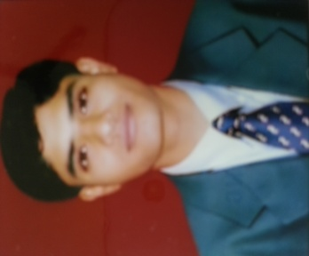**ADITYA PRASAD DAS**

**AT:- BEERAJAGANNATHPUR SASAN**

**PO:- BADAKHARIDA**

**DIST:- GANJAM**

**STATE:-ODISHA**

**PIN:-761041**

**E-mail**:- **adityaprasaddas1989@gmail.com**

**phone: 9937052107 /9861466435**

**CAREER OBJECTIVE:**

**To hold a position in a result oriented company that seeks ambitious and career conscious individuals, where my acquired skills and education will be utilized toward continued growth and advancement.**.

**WORK EXPERIENCE**

1. **VEDANTA ALUMINIUM LIMITED**

**India’s first 330 kA pre-baked Aluminum smelter with proposed 1.8 million tones/annum production capacity.**

**WORKED as a ICM stacking operator in VEDANTA ALUMINIUM LTD 4 yrs i.e (From 17.07.2009 to 17.06.2013)**

**EDUCATIONAL QUALIFICATION:**

|  |  |  |  |  |  |
| --- | --- | --- | --- | --- | --- |
| Examination | Discipline/  Specialization | School/college | Board/  University | Year of Passing | % |
| +3(Bsc.) | Chemistry | Tara Tarini College, purushottampur | Berhampur university(BU) | 2009 | 63% |
| Intermediate | Science(MPCB) | K.B.V Mahabidyalaya, K.s. Nagar | CHSE  Orissa | 2006 | 59% |
| 10th | General | Sri kaleswar high school,Badakharida | Board of Secondary  Education, Orissa | 2004 | 60% |

**CERTIFICATIONS:**

* **Post Graduate Diploma In Banking Management (PGDBM) from TimesPro.**
* **Knowledge On Finacle v10..**

**Personal assets**

* **Team Builder and planner with a will to work hard.**
* **Easily acclimatize to any environment.**
* **Comprehensive problem solving abilities.**
* **Good Leadership Qualities & management skills.**

**PERSONAL PROFILE:**

**Name : ADITYA PRASAD DAS**

**Date of Birth : 07-05-1989**

**Sex : Male**

**Marital Status : Single**

**Nationality : Indian**

**Hobbies : Making new friends, Reading news paper**

**Languages Write : Oriya, English, Hindi**

**Languages Speak : Oriya, English, Hindi**

**Declaration:**

**I hereby declare that the above-mentioned information is correct up to my knowledge and I bear the responsibility for the correctness of the above-mentioned particulars.**

**Place :**

**Date :** (Aditya Prasad Das)